**Load balancer stickiness:**

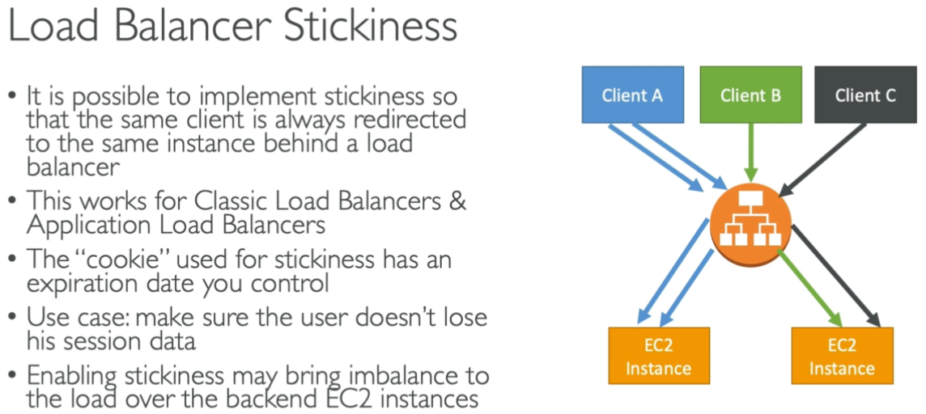

* Stickiness will be helpful when we want a client request to be redirected to the same server.
* Stickiness can be enabled in the target groups of ALB.

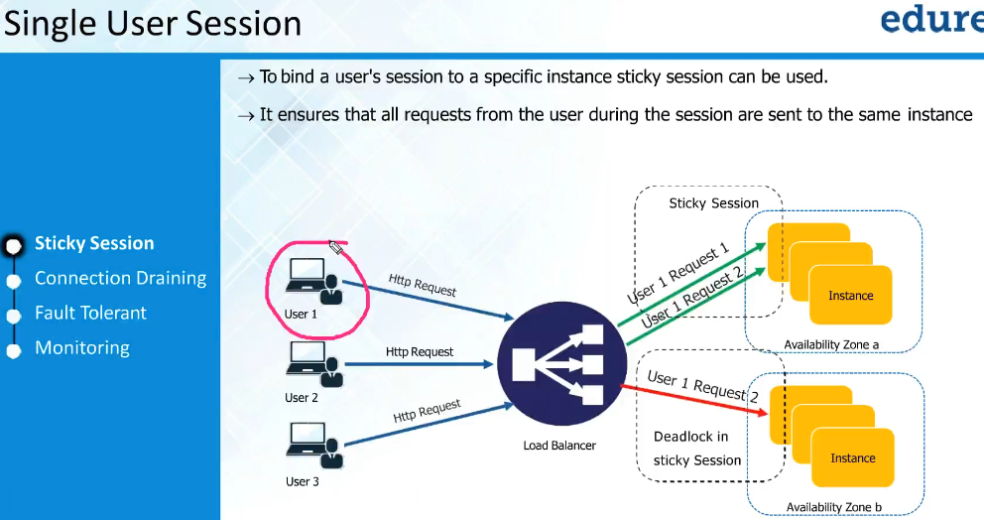

* Sticky session means all the request from the user will be sent to same machine where the user session created
* We need to edit the attributes as below.

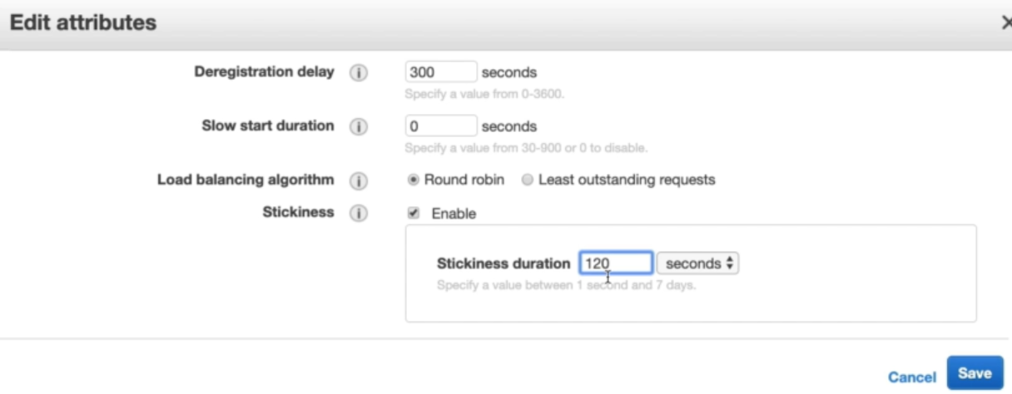

* Once we enable the stickiness, the traffic from the same user will go to the same server where the first connection created
* As above, we gave 120 second which means 2 mins duration for stickiness. So, when a client hits the LB, the sticky connection will be enabled to one server and will last for 120 secs. So, in that 120 secs, if same client his LB again and again, it will be redirected to same server. It may change to another server after120 secs only.
* May be this feature in required for the secured websites where user need to be authenticated every time they redirected to new page. So, we may don’t want the connection to happen to new server for every new page. If the client is connected to same on server, then no need to get authenticated every time.